National Peatland Action Programme (NPAP) project P25COM024: Ecologist brief

# Project Title: Peatland restoration and sustainable management combining several neighbouring upland areas: Surveying, Mapping and Restoration Planning

# Overview

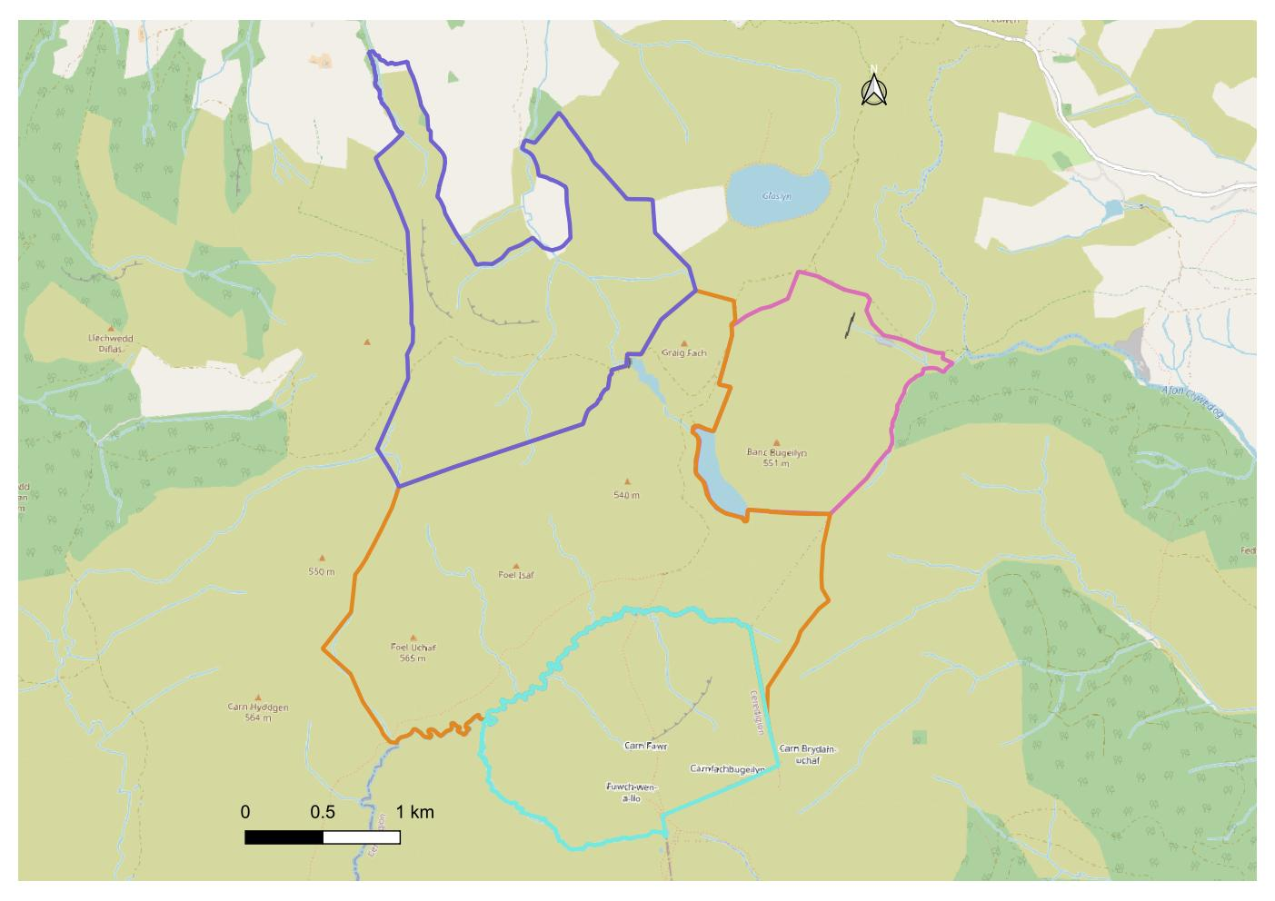Having been awarded funding under the National Peatland Action Programme (NPAP), Montgomeryshire Wildlife Trust is looking for a suitably experienced ecologist to carry out ecological, peat and hydrological surveys and use this information, along with existing data, to write peatland restoration and habitat management plans for each of the four areas shown on the map below. The total project area is: 1,073ha and is located in the Cambrian Mountains between Staylitte and Machynlleth, Powys; central grid reference: SN815928.

# Key dates

* Fieldwork to be completed by 31st October 2025
* Production of draft peatland restoration and habitat management plans by 30th November 2025
* Final costed peatland restoration and habitat management plans completed by 28th February 2026

# Project deliverables

For each of the four areas within the project we need:

* Desk survey using BIS data of Protected & Priority Species, Invasive species INNS, Statutory & Non-statutory Sites and existing Phase 1 Habitat maps within 1km.
* Peat rapid assessment protocol surveys, recording peat condition and depth data, as well as DOMINS vegetation composition and quality. Evidence of all priority habitats and species likely to be impacted should also be recorded.
* Ecological Assessment Summary report detailing the desk and field survey results.
* Costed peatland restoration plan and habitat management plan.
* GIS data shared with MWT & raw biological records submitted to BIS.

# Experience/qualifications/licenses needed

* Ecologist(s) with experience of conducting all of the work detailed above

# Context

This project builds on work carried out recently on an adjacent holding, where restoration is now underway. The project aims to carry out a detailed peatland restoration feasibility and development study of an approximately 1,073 hectare area of upland habitat (with significant amounts of peatland). Through peat depth and ecological surveying, and detailed discussions and negotiations with the four farms that own and manage the area, we aim to establish their requirements and constraints in relation to peatland restoration. Habitat management plans and restoration guidance for peatland habitats will take into account the constraints and opportunities associated with the farm business contexts. The landowner liaison will be carried out under a separate Contract; this person will be available to help arrange site access and facilitate input of farm requirements and constraints when the habitat management and restoration plans are being developed.

# MWT Project Officer

Tammy Stretton, Conservation Officer; [tammy@montwt.co.uk](mailto:tammy@montwt.co.uk); 07572 917164