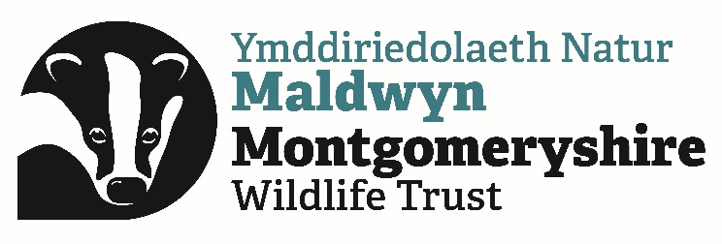

MWT Wind farm position statement
The latest State of Nature (2023) reports that climate change, along with the way we manage land for agriculture, is having the biggest impacts on our wildlife. For this reason, Montgomeryshire Wildlife Trust (MWT) supports the move away from fossil fuels, towards renewable energy. In the UK, we are faced with significant challenges on how to deliver this appropriately and at pace. An increase in the use of renewable sources of energy is urgently needed, and MWT consider that wind power can help to meet the energy requirements of the UK in a sustainable manner. However, windfarms should not be located in areas where their known direct impacts on wildlife are likely to be severe or would cause significant damage to a protected or irreplaceable* habitat. Windfarms must be constructed in a way that minimises the damage to the immediate environment, even where this increases the cost of construction. Further, ongoing management of the operational site should deliver on habitat management objectives which maintain and enhance the biodiversity and ecosystem functioning of the area to the greatest possible extent.
- Through our work we will lobby to ensure that any proposed wind energy generation projects adhere to planning policy
- We will oppose projects which fail to reach the standards detailed above
- Where projects are given planning permission, we will work to ensure the best possible outcomes for wildlife

* The newly updated (October 2023) Chapter 6 of Planning Policy Wales defines these habitats as “Habitats, including the natural resources which underpin them, which would be technically very difficult (or take a very significant time) to restore, recreate or replace once destroyed, taking into account their age, uniqueness, species diversity or rarity.” Examples specifically mentioned include “peatland” and “blanket bog”. PPW states that “Such sites form the heart of resilient ecological networks and their role and the ecosystem services they provide must be protected, maintained and enhanced and safeguarded from development. It will be wholly exceptional for development to be justifiable in such instances.”
Chapter 6 also includes a paragraph on “Peatlands”, which states the following: “Peat soils are extremely fragile and if compromised put at risk the resilience of the ecosystems they support. Peatland habitats cover only 3-4% of Wales yet store in the region of 20-25% of all soil carbon. Where peat is identified within proposed developments considerable weight should be given to its protection because of its special importance in underpinning and supporting national natural resources such as soil carbon, biodiversity and flood management, and unless other significant material considerations indicate otherwise it will be necessary to refuse permission.”

Jan 2024

