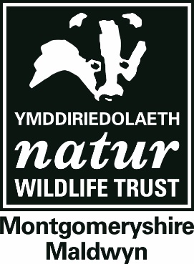
Montgomeryshire Wildlife Trust

Policy on Safeguarding
Children and Vulnerable Adults

Contents:

- Policy
- Appendix 1 - Code of Practice (Children)
- Appendix 2 - Code of Practice (Vulnerable Adults)
- Appendix 3 – Reporting Process
- Appendix 4 - Regulated Activity
- Appendix 5 - Ratios
- Appendix 6 - Staff Mobile Phones
- Appendix 7 - Code of Conduct for Delivery of Online Activities

Rationale
The Montgomeryshire Wildlife Trust employs and engages with people from a wide range of backgrounds and circumstances in its mission to “rebuild biodiversity and engage people with their environment”. This policy and associated procedures are intended to protect children, vulnerable adults, staff (including volunteers and trainees) and the Montgomeryshire Wildlife Trust. It aims to provide a clear framework for staff and volunteers so they know what is expected of them, to work safely and to minimise stress.

Policy
- The Trust will seek to provide an environment where children and vulnerable adults will be safe from harm.
- The Trust will adhere to legislation and good practice as provided by the various agencies involved in children and adult welfare and safety.

Policy Implementation
To implement the policy, a set of procedures and guidelines have been developed. This policy is regularly reviewed with input from staff, Trustees and key volunteers. The Trust’s CEO and Health and Safety Officer take a lead role around safeguarding but it is acknowledged that all staff and volunteers have a role to play in delivering the Trust’s Safeguarding Policy.

- Safe Recruitment
1.1 We will seek to recruit using appropriate procedures, safeguards and checks.

1.2 We will take up references for all staff posts that involve working with children and vulnerable adults prior to appointment.

1.3 We will identify which roles are determined to be a Regulated Activity* and require a barring list check. All other roles, including that of Chair, will be subject to a Basic DBS check. MWT will use the Disclosure & Barring Service (DBS) to perform these checks.

1.4 We will assess any criminal record information that is disclosed in line with our data protection and equalities (treating ex-offenders fairly) policies.

1.5 We will provide an induction programme for all new staff, appropriate training to enable all personnel to undertake their roles safely and confidently, and ongoing training as benefits the personal and professional development of individuals and of our organisation. We will also update our training of new and existing staff in response to changes in internal guidelines or external legislation.

  - We will regularly review our staff and volunteer recruitment procedures in response to changes in legislation and systems external to our organisation e.g. DBS and barring list checks.

- Volunteers
2.1 The Trust maintains and updates a “Volunteer Handbook” which covers the support and management that volunteers working with the Trust can expect.

2.2 Any volunteer roles, involved in a regulated activity* are expected to conform to this policy and the guidance set for staff.

- Responsibility for Safeguarding
3.1 The Trust’s CEO and Health and Safety Officer will provide an important role in supporting staff, volunteers and members. The role is potentially demanding so support for the two officers, both mutual and from the Trustees, is vital.

3.2 The Trust’s CEO (clive@montwt.co.uk) and Health and Safety Officer (eley@montwt.co.uk)
will be available to all staff, volunteers and service users to speak to when they have any concerns, issues or complaints regarding the safety, well-being or conduct of service users, volunteers and staff.

3.3 The Trust’s CEO and Health and Safety Officer will have access to appropriate training to support them in these roles. They will liaise with appropriate local and national agencies, contribute to appropriate policies, maintain records and keep confidentiality, adhere to and promote this policy within the organisation, and support or provide access to support for individuals suffering harm or abuse.

3.4 Where appropriate, each project team will have a designated Safeguarding Lead. If a safeguarding concern is identified, the staff member(s) will raise the concern with the Safeguarding Lead in the first instance. The Safeguarding Lead will then follow the reporting process (See Reporting Process Flow Chart – Appendix 3). The Safeguarding Lead can call upon the support and advice of the CEO and/or Health and Safety Officer in any safeguarding matter. The Safeguarding Lead will be offered appropriate training to fulfil this role.

- Awareness of harm and abuse in our organisation
4.1 Harm is caused by accidents, deliberate abuse (physical, sexual, emotional, financial), neglect (deliberate or not) or factors such as bullying, prejudicial attitudes or a failure to enable a person to participate in activities that are open to most of their peers.

4.2 All incidents of harm to anyone involved in our service will require an appropriate response to reduce risks and improve our service.

4.3 Deliberate acts of harm (sexual, physical, emotional and financial) and neglect are abuses against the person and will incur disciplinary proceedings and require reports and referrals to social services, the police, other professional bodies and the Disclosure and Barring Service (DBS) if in regulated activity*. See Appendix 3 for Reporting Guidance.

  - Where there is risk of significant harm to our service users, volunteers or staff, the Trust CEO and/or Health and Safety Officer are empowered to act accordingly:
- To log all conversations regarding the issue
- To sign and request signatures on reports and statements
- To confidentially seek advice from expert sources
- To share concerns (with consent where required and appropriate) internally with the Chair of the Council
- To share concerns and make referrals to external agencies such as Social Services, the Police or NSPCC as appropriate to the circumstances, with the intention of disclosing all information within 4 hours of discovery of the issue
- Make a referral to the Disclosure and Barring Service regarding staff or volunteers in regulated activity whose conduct is harmful to service users and when they are removed from regulated activity

  - Where there is a risk of significant harm to our service users, volunteers or staff from the Trust’s CEO or Health and Safety Officer:
- Speak to the Trust Chair and inform them of your concerns.
- Log all conversations and information yourself pertaining to the issue
- Confidentially contact an external source for advice pertaining to the issue (such as the NSPCC helpline).
- Do also inform another member of staff who is not directly or indirectly linked to the incident for support.
- If the issue is identified to be/could be a safeguarding issue, immediately contact social services for advice and guidance.

- Confidentiality
  - All reports and logs (including personnel records) will be kept securely and confidentially according to our “Privacy Policy” and “Data Retention Policy” and good practice in confidentiality (See Staff Handbook) or in line with DBS Code of Practice if appropriate, until or unless it is necessary to share this material with the agencies named above. Information will be shared on a “need-to-know” basis only.

- Communication
  - We will make this policy available to all staff, volunteers, users of our service and their families / carers, using appropriate methods, formats and language to ensure that the policy is clear and easy to understand.

  - We support and encourage all users of our service, volunteers and staff to speak up and contact the Trust’s CEO or Health and Safety Officer where there is:
- a concern (a worry, issue or doubt about practice or treatment of a service user or colleague, or their circumstances), or
- a disclosure (information about a person at risk of or suffering from significant harm) or
- an allegation (the possibility that a volunteer or staff member could cause harm to a person in their care)

  - Staff or volunteers can report things that are not right, are illegal or if they believe that anyone at work is neglecting their duties, putting someone’s health and safety in danger or covering up wrongdoing. In the first instance they should speak with the Trust’s CEO or Health and Safety Officer.

  - We would prefer our members and personnel to use internal processes whenever possible to make a report as above, but this does not prevent them from making a report or referral to statutory agencies such as Social Services or the Police, in their own right as a private individual. We also support our staff or volunteers to raise concerns or to disclose information, which they believe shows malpractice - whistle-blowing (disclosure in the public interest).

Policy adopted on behalf of MWT Council by Tim McVey (Chair) on 30th January 2021

Reviewed Date: 16/10/2021

Signature.......................

*Note Regulated activity is work that a barred person must not do, in relation to contact with children and young people, and vulnerable adults and these are laid out in guidance published by the Disclosure and Barring Service.

For more information see Appendix 4

APPENDIX I

CODE OF PRACTICE FOR STAFF AND VOLUNTEERS WORKING WITH CHILDREN
A Child is any young person under the age of 18
A Carer is the adult legally responsible for the child (e.g. parent, guardian, teacher or Group Leader)
A Leader is a Wildlife Trust staff member or volunteer running activities
A Group Leader is a leader of an external group, (e.g. youth group or play scheme)

Staff and volunteers running activities (Leaders) must never behave in ways that could cause distress to children. You must be aware of the acceptable and unacceptable standards of behaviour as laid out in this Code of Practice.

You should:
- Set a good example; you are likely to be seen as a role model and should adopt an approach that encourages mutual respect.
- Ensure adults are present according to the appropriate ratios (see Appendix 5).
- Obtain written consent from the carer before having, unsupervised, contact with a child
- Always respect a child’s right to privacy and personal space.
- Be alert to inappropriate or potentially harmful behaviours within a group
- Treat group members as individuals and value everyone’s comments and contributions.
- Always seek the agreement of a child if you need to touch them to administer first aid or to help with clothing.
- Respond sensitively to children anxious or unsure about participation in any activities.
- Encourage a culture of openness, where a child feeling upset is able to talk about it.
- Immediately report any concerns you have about the welfare or safety of any child, or of inappropriate behaviour of other adults (see Appendix 3).
- Ensure participants are aware of who is responsible for the group.
- Adopt a going home or winding up procedure to minimise the chance of children coming to harm once the planned activities are complete.
- Ensure other adults attending a group or family event (e.g. parents) recognise the need for appropriate behaviour around children.
- Ensure that if staff or volunteers under 18 are working with children, they do not have a responsible role. They may lead or assist as long as other adults are present according to the appropriate ratios although they will be expected to act in a positive way.
- Follow MWT’s photography code of conduct

You should not:
- Rely on your good name to protect you from allegations.
- Be alone with a child. If a degree of privacy is required then you should aim to remain within sight or earshot of other people.
- Show favouritism within the group or be drawn into attention-seeking behaviour such as crushes or tantrums.
- Allow or engage in suggestive remarks, gestures or touching which could be misunderstood or misconstrued.
- Engage in rough or physical contact unless it is permitted within the rules of a game or activity.
- Smoke, or be under the influence of alcohol or drugs whilst around young people, whether you are acting in a supervisory capacity or not.
- Swear or use explicit language

AppeNdix 2

CODE OF PRACTICE FOR STAFF AND VOLUNTEERS WORKING WITH VULNERABLE ADULTS

A Vulnerable Adult is a person over 18 years old who is, or may be, in need of community care services because of their: • learning disability • physical disability • sensory disability • mental health • illness • age • misuse of alcohol or drugs. A vulnerable adult has problems protecting themselves against harm, abuse or being taken advantage of.
A Carer is someone who takes responsibility for the well-being and behaviour of a vulnerable adult for the duration of, and transport to and from their engagement with us.

It is key that staff and volunteers running activities never cause distress of any kind to vulnerable adults. You must be aware of the acceptable and unacceptable standards of behaviour as laid out in this Code of Practice.

You should:
- Talk to a carer, if applicable, to gain awareness of any particular needs/concerns and to be aware of any particular stresses that can be caused inadvertently to their condition
- Always respect an individual’s right to privacy and personal space.
- Be alert to inappropriate or potentially harmful behaviours within a group
- Treat group members as individuals and value everyone’s comments and contributions.
- Always seek the consent of a vulnerable adult if you need to touch them to administer first aid or to help with clothing.
- Respond sensitively to vulnerable adults anxious or unsure about participation in any activities.
- Encourage a culture of openness, where anyone feels upset feels is to talk about it.
- Immediately report any concerns you have about the welfare or safety of any vulnerable adult, or of inappropriate behaviour of other adults.
- Ensure participants are aware of who is responsible for the group.
- Be aware of the numbers and needs of participants. Adopt a going home or winding up procedure to minimise the chance of vulnerable adults coming to harm once the planned activities are complete.
- Respectfully ensure other adults attending a group event recognise the need for appropriate behaviour around vulnerable adults.
- Be aware of permissions concerning photography (see below)
- Follow MWT’s photography code of conduct

You should not:
- Rely on your good name to protect you from allegations.
- Be alone with a vulnerable adult. If a degree of privacy is required then you should aim to remain within sight or earshot of other people.
- Show favouritism within the group.
- Allow or engage in suggestive remarks, gestures or touching which could be misunderstood or misconstrued.
- Engage in rough or physical contact unless it is permitted within the rules of a game or activity.
- Smoke, or be under the influence of alcohol or drugs whilst around vulnerable adults, whether you are acting in a supervisory capacity or not.
- Swear or use explicit language.

APPENDIX 3

REPORTING
Any Safeguarding concerns about the welfare or safety of any child or vulnerable adult must be reported immediately.
The Safeguarding Reporting Flow Chart shows the reporting process and identifies who needs to be notified.
The Safeguarding Concern Reporting Form is used to capture all the relevant information of an incident or concern.
Useful Contact Information
Powys County Council Child Services
Email: people.direct@powys
Telephone: 01597 82766 (Mon to Thurs 8.45am to 4.45pm, Fri 8.45am to 4.15pm)
Out of Hours Telephone: 0845 05404847
Or visit https://en.powys.gov.uk/article/1514/Report-Child-Abuse to complete an online reporting form.
Powys Police
You can call 24 hours a day, 7 days a week on 101
Other professionals
You can also speak to other professionals such as a doctor, health visitor, teacher, or the NSPCC who can advise you and put you in touch with a social worker or police officer, or who can pass on information on your behalf.

In an emergency – Don’t Wait – call 999

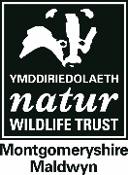
Safeguarding Concern Form

Please complete this form if you witness or are made aware of a
Safeguarding incident or concern. Pass this completed form to the appropriate
person shown on the Safeguarding Reporting Flowchart.

Reporter’s Name
Date of Incident |  | Time of Incident
Location of Incident
Individual(s) involved
ACTIONS TAKEN
Action | Person Taking Action | Date Completed | Signature

Concern/Incident Report (please describe in as much detail as possible using another piece of paper if necessary)

Signature: Date:

Incident Investigation Closed
Date
Signature

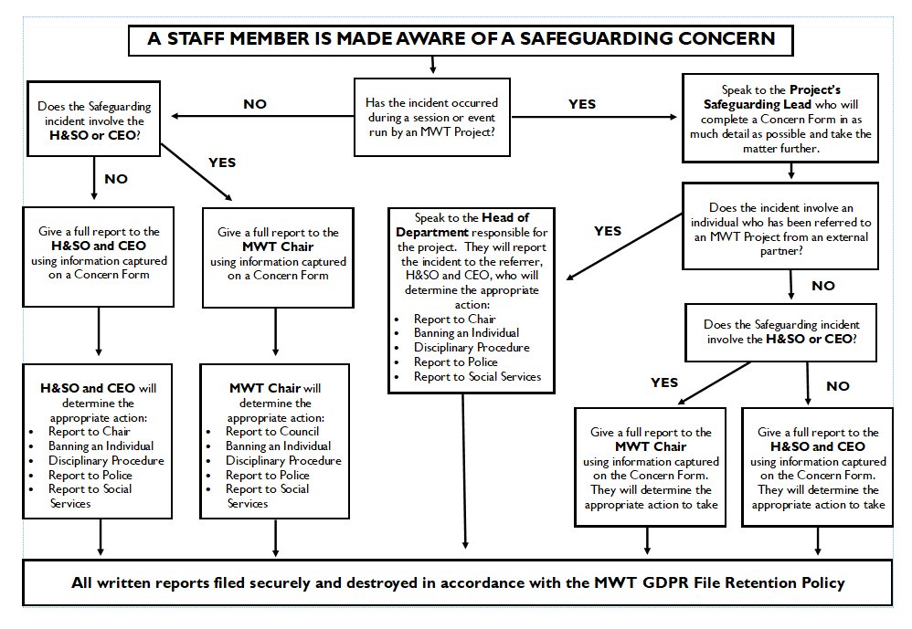

APPENDIX 4

A Regulated Activity is activity that you must not do if you are barred from working with children or vulnerable adults

The scope of Regulated Activity for work with children and young people is:

- Unsupervised activities: teaching, training, instructing, caring for or supervising children, or providing advice / guidance on well-being, or driving a vehicle only for children

- Work for a limited range of establishments (‘specified places’), with opportunity for contact. For example – schools, children's homes, childcare premises (but not work by supervised volunteers)
Work under (1) or (2) is Regulated Activity only if done regularly. In this context, ‘regular’ means carried out by the same person frequently (once a week or more often), or on 4 or more days in a 30-day period (or in some cases, overnight).

- Relevant personal care, for example washing or dressing; or health care by or supervised by a professional, even if done once.

- Registered child-minding and foster-carers

The issue of whether or not activity is considered to be Regulated under the new definition may depend in many cases on whether it is supervised or not. The legal definition of supervision in the Protection of Freedoms Act 2012 states that the supervision should be:
- ‘regular’
- ‘day to day’
- ‘reasonable in all the circumstances for the purpose of protecting the children concerned’,
and
- ‘carried out by someone who is in regulated activity’
The DBS website has detailed information, helpful reports and guidance on particular topics which are regularly updated.
The DBS also provides information and help via:
- email – customerservices@dbs.gsi.gov.uk
- Disclosure helpline 03000 200 190 and minicom 03000 200 192

APPENDIX 5

The following table shows the recommended minimum adult to child ratios MWT have adopted. These are partially based on Ofsted guidelines.

MWT staff are never solely responsible for the children and vulnerable adults attending MWT events. The recommended minimum ratio of two Adults (shown below) would include at least one MWT staff member and one teacher, carer or parent in attendance throughout the event.

Child's  age | Number of  adults (Minimum) | Number of  children
0-2 | 2 | 3
2-3 | 2 | 4
4-8 | 2 | 6
9-12 | 2 | 8
13-18 | 2 | 10

APPENDIX 6

Staff should not store photographs of children and vulnerable adults on their personal phones and cameras. Some staff use personal phones and cameras for Trust purposes and others have designated Trust owned phones. Status is outlined below.

Each staff member using their own phone or camera to take Trust-related images must downloaded those images to the relevant media folder on the central S Drive fortnightly, and at the same time delete them from their own phone or camera.

Volunteers are not permitted to use their own phones/camera to take photos of people but may be asked to do so using a staff member’s phone/camera.

Name | Trust-owned phone | Staff-owned phone used for Trust work | Trust owned camera | Staff-owned camera used for Trust work
Clive Faulkner | N | Y | N | N
Eley Hart | N | Y | N | N
Emyr Evans | N | Y | N | Y
Ceri Jones | N | Y | N | N
Carla Kenyon | N | Y | N | N
Dewi Morris | N | Y | N | N
Dan Hodgkiss | Y | Y | N | N
Rob Haigh | N | Y | N | N
Tammy Stretton | N | Y | N | N
Sandy Scott | N | Y | N | N
Fay Morris | Y | Y | N | N
Nadine England | N | Y | N | N
Janine Pannett | N | Y | N | N
Kim Williams | N | Y | N | N
Frances Louise | Y | N | N | N
Eurig Jones | Y | N | N | N
Jo Walker | Y | N | N | N
Mark Harding | Y | N | N | N
Alex Chadwick | N | Y | N | N
Sarah Tack | N | N | N | N

APPENDIX 7

Code of Conduct for Delivery of Online Activities

For Staff:
• Follow our current safeguarding guidance as closely as possible (i.e. No significant time alone with young people, avoid personal details, raising concerns immediately etc.)
• Think about what platform is best to use for your session and audience. Different platforms and apps come with different privacy settings, age ratings and risks. Please read the NSPCC Net Aware risk guidance for more information: https://www.net-aware.org.uk/networks
• Think about your delivery set up as you would ordinarily – is the environment that is under your control suitable for delivery (is there a bland background, will you be uninterrupted, is there anything personal you don’t want seen, act, dress and behave as you would in normal face to face delivery)
• Be clear with participants about your working times/ contact times
• Make sure that participants/ parents/ support workers are clear about the code of conduct.
• Report any issues immediately to MWT’s CEO or Health and Safety Officer.

For Participants
With this group, we hope to create a safe space online where you feel happy to join in our sessions and talk to us if you need to.

What you can expect from us:
• Interesting activities
• An opportunity to express your creativity/thoughts/opinions about wildlife and wild spaces
• People to talk to

What we expect - for you to turn up to sessions as you would if we were meeting face to face i.e.
• on time
• fully dressed (not in PJs)
• being mindful of your language
• being respectful to the other people in the session
• ideally in a quietish space if you can find one
• mute your microphone when not speaking so that the sound quality is better for everyone

A few things to know - your safety:
• There will usually be another member of staff in the sessions with us to help things run smoothly
• Please remember that you are online. Don’t post anything that you might want to take back later.
• Please do not record video or take screenshots without prior consent and permission.
• We can’t promise to keep anything confidential. If we think you or someone else is at risk of significant harm we may need to talk to someone else about it.

If you are feeling unhappy or isolated and need to talk – these are some good places to turn to. Each website also has lots of videos and articles to read on different subjects.
- All of these have call lines, online support and lots of articles/ tips.
- Kooth – online help for young people and adults - https://www.kooth.com/
- The Mix – Online and phone help for under 25’s. 0808 808 4994 https://www.themix.org.uk/
- Childline – 0800 1111- https://www.childline.org.uk/
- Mind - https://www.mind.org.uk/ -
- www.counselling-directory.org.uk

other than those available from a pharmacist or prescribed by your doctor and for which no relevant side effects are expected.
other than those available from a pharmacist or prescribed by your doctor and for which no relevant side effects are expected.

