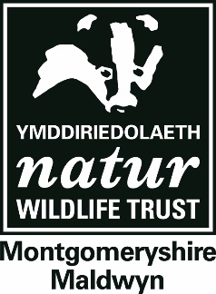

**EYFS Programmes**

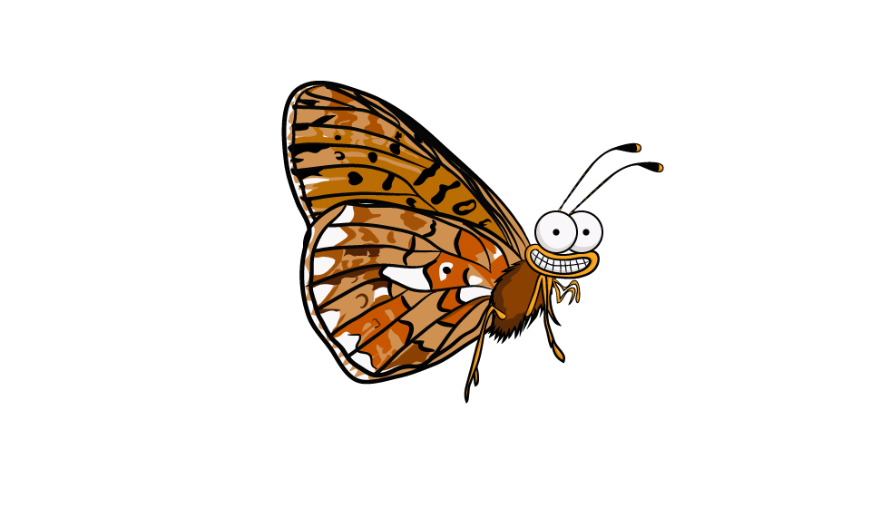

**OUTDOOR LEARNING**

**Our Early Years and Foundation Stage programmes are specifically designed to allow children to explore and discover the natural world in a safe and exciting environment.**

Our education programme can either be delivered at five of our 18 nature reserves or brought to other sites, be they schools or other personal grounds. Sessions are led by experienced staff who are first aid trained and DBS checked to give you peace of mind and your class a unique immersive experience. A day typically runs from 10:00-14:15, including a break for your packed lunch.



**Physical development**

**Communication & language**



**Understanding the world**



**Expressive arts & design**

**Personal, social & emotional development**

**Literacy**

**Maths**

**Caterpillar Life Cycles**



**Natural Art**

Children will create varied pieces of art using natural materials and the wonderful colours abundant in nature.



This session uses games and activities to lead children through the lifecycle of a Pearl-bordered Fritillary Butterfly. Depending on the time of year, they will go on a hunt for caterpillars and butterflies or explore a range of habitats for other mini-beasts so that they can have a closer at these weird and wonderful creatures.

**Pond-dipping**



**Trees for all seasons**



**Mini-beast Hunting**



The children will hunt in small groups, collecting pond creatures and recording what they find. We will then study them in more depth with our ‘show and tell’ sessions.

The children will study the trees on their school grounds/one of our reserves. They will learn how to identify them, work out how old they are, why they are so important for wildlife and explore them through seasonal activities and games.



The children will hunt in small groups, collecting mini-beasts with a range of methods (including beat-sheets and sweep-nets), recording what they find. We will then study them in more depth with our ‘show and tell’ sessions.

**Creatures of the Night Workshop**

This workshop will look at which creatures inhabit the habitats at night. The children will learn about tracks and signs left by nocturnal animals. This will lead to barn owl pellet dissection. The children will make a bat hat or a clay hedgehog to take home.



This session aims to get kids out and their hands in the dirt! Children will get to plant their own meadow or tree seeds, or plant out baby trees from our nature reserves, to grow either at school, a local wildlife site, at home or anywhere they want to create habitat for wildlife!



**Green Thumbs**

This session seeks to raise awareness of good welfare and practice when approaching wildlife. Children will work in groups to make their own puppets, and act out what to do when they find a baby bird on the ground, a sick hedgehog or a spider in the bath!



**Wild Aware**

This session looks to involve parents and children and members of the community to improving a local area for wildlife. Depending on the space in question, we provide materials and expertise to create ponds, bug hotels or bird boxes in dedicated training workshops. Duration and cost of this session vary between the kind of habitat being created and the size of the area used.



**Homes For Nature**

This session will be a celebration of Christmas and its place in the natural world. The children will learn about how Christmas can be made more environmentally sustainable. Make green gifts such as nest boxes and bird-feeders, turn recycled cards into gift-boxes, new cards & labels and make Christmas decorations from natural materials, which may even feed the birds.



**Green Christmas**

Children will test their survival skills by learning to make a fire or building a shelter in the woodland, among other woodwork skills. As part of the session, they’ll make a Boghart (tree spirit) out of clay, learn about native plants and animals and play woodland games!

**Bushcraft**

